Packet Tracer - TCP and UDP Communications

**Notes:**

1. This document contains the instruction and questions that you need to answer for the Packet Tracer activity named wk5-computer-prac-PKA-a-TCP-UDP-Communications.pka.
2. Make sure you have downloaded and opened the Packet Tracer activity file named wk5-computer-prac-PKA-a-TCP-UDP-Communications.pka.
3. Follow the instruction in **this** Word document to complete the Packet Tracer activity.
4. Type in your answer to EACH question included in this document, immediately after the question in the space provided.
5. Save this Word document and submit it as part of your Week 5 Computer Practical submission.
6. **Topology**

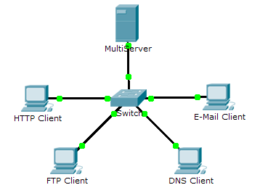

# Objectives

Part 1: Generate Network Traffic in Simulation Mode

Part 2: Examine the Functionality of the TCP and UDP Protocols

# Background

This simulation activity is intended to provide a foundation for understanding TCP and UDP in detail. Packet Tracer simulation mode provides you the ability to view the state of different PDUs as they travel through the network.

Packet Tracer Simulation mode enables you to view each of the protocols and the associated PDUs. The steps outlined below lead you through the process of requesting network services using various applications that are available on a client PC. You will explore the functionality of the TCP and UDP protocols, multiplexing, and the function of port numbers in determining which local application requested the data or is sending the data.

## Generate Network Traffic in Simulation Mode and View Multiplexing

### Generate traffic to populate Address Resolution Protocol (ARP) tables.

Perform the following task to reduce the amount of network traffic viewed in the simulation.

* + - 1. Click **MultiServer** and click the **Desktop** tab > **Command Prompt**.
      2. Enter the **ping -n 1 192.168.1.255** command. You are pinging the broadcast address for the client LAN. The command option will send only one ping request rather than the usual four. This will take a few seconds as every device on the network responds to the ping request from **MultiServer**.
      3. Close the **MultiServer** window.

### Generate web (HTTP) traffic.

* + - 1. Switch to Simulation mode.
      2. Click **HTTP Client** and open the **Web Browser** from the desktop.
      3. In the URL field, enter **192.168.1.254** and click **Go**. An Envelope (PDU) will appear next to the HTTP client in the topology window and show in the Event List of the Simulation Panel too.
      4. Minimize, but do not close, the **HTTP Client** configuration window.

### Generate FTP traffic.

* + - 1. Click **FTP Client** and open the **Command Prompt** from the desktop
      2. Enter the **ftp 192.168.1.254** command. A PDU will appear next to the FTP client in the topology window and show in the simulation window too.
      3. Minimize, but do not close, the **FTP Client** configuration window.

### Generate DNS traffic.

* + - 1. Click DNS Client and open the **Command Prompt**.
      2. Enter the **nslookup multiserver.pt.ptu** command. A PDU will appear next to the DNS client in the topology window and show in the simulation window too.
      3. Minimize, but do not close, the **DNS Client** configuration window.

### Generate Email traffic.

* + - 1. Click **E-Mail Client** and open the **E Mail** tool from the Desktop.
      2. Click **Compose** and enter the following information:
         1. **To:** user@multiserver.pt.ptu
         2. **Subject:** Type in your own personalized subject line
         3. **E-Mail Body:** Type in your own personalized Email body
      3. Click **Send**. A PDU will appear next to the E-Mail client in the topology window and show in the simulation window too.
      4. Minimize, but do not close, the **E-Mail Client** configuration window.

### Verify that the traffic is generated and ready for simulation.

There should now be PDU entries in the simulation panel for each of the client computers.

### Examine multiplexing as the traffic crosses the network.

You will now use the **Capture/Forward button** in the Simulation Panel to observe the different PDUs travelling on the network.

**Note**: The **Capture/Forward** button ‘ **►|** ‘ is a small arrow pointing to the right with a vertical bar next to it.

* + - 1. Click **Capture/Forward** once. All of the PDUs travel to the switch.
      2. Click **Capture/Forward** six times and watch the PDUs from the different hosts as they travel on the network. Note that only one PDU can cross a wire in each direction at any given time.

#### Questions:

What is this called?

Your Answer: This is called multiplexing

A variety of PDUs appears in the event list in the Simulation Panel. What is the meaning of the different colors?

Your Answer: The different colors represent for different protocols

## Examine Functionality of the TCP and UDP Protocols

### Examine TCP connection establishment and HTTP traffic as the clients communicate with the server.

* + - 1. Click **Reset Simulation** (in the Simulation Panel, below the Event List).
      2. Filter the traffic that is currently displayed to only **HTTP** and **TCP** PDUs. To filter the traffic that is currently displayed:
         1. Click **Edit Filters** (at the bottom of the Simulation Panel) and toggle the **Show All/None** button.
         2. Click the **Misc** tab, and then select **HTTP** and **TCP**. Click the red “x” in the upper right-hand corner of the Edit Filters box to close it. From now on, visible Events should display only **HTTP** and **TCP** PDUs.
      3. Open the browser on HTTP Client and enter **192.168.1.254** in the URL field (the address might be there already, then you don’t need to enter it again). Click **Go** to connect to the server over HTTP.
      4. Minimize the HTTP Client window.
      5. Click on the (green) PDU envelope that the HTTP client is going to send, and then Click the **Outbound PDU Details** tab and scroll down to the TCP section.

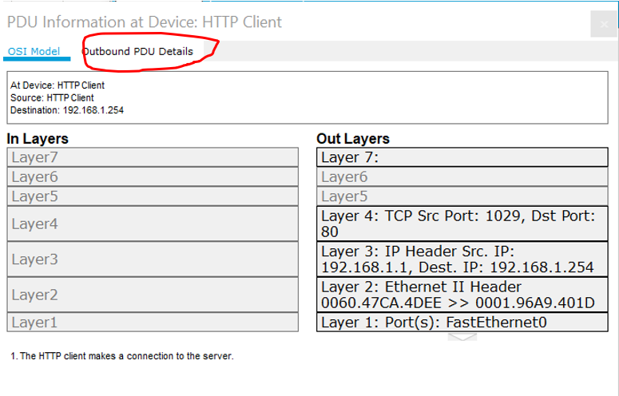

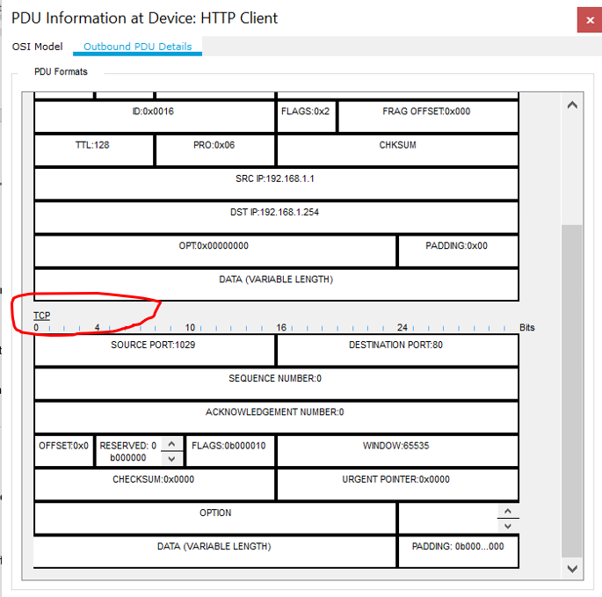

* + - 1. Look at the values in the FLAGS field, which is located next to the WINDOW field.

In the FLAGS field, the values **to the right of the “b”** represent the TCP flags that are set for this stage of the data conversation. As shown in the table below, each of the six places corresponds to a flag. The presence of a “1” in any place indicates that the flag is set. More than one flag can be set at a time.

|  |  |  |  |  |  |  |
| --- | --- | --- | --- | --- | --- | --- |
| Flag Place | **6** (left most, i.e. the place immediately next to “b”) | **5** | **4** | **3** | **2** | **1** (right most) |
| Flag name | URG | ACK | PSH | RST | SYN | FIN |

#### Question:

Which TCP flag is set in this PDU (write down the Flag name)?

Your Answer: SYN

* + - 1. Close the PDU and click **Capture/Forward** twice, click the PDU envelope at the **MultiServer** to open it.
      2. Click the **Outbound PDU Details** tab and scroll down to the TCP section.

Which TCP flags are set in this PDU (write down the flag names)?

Your Answer: ACK and SYN

* + - 1. Close the PDU and click **Capture/Forward** twice, click the **green** PDU envelope at the HTTP client (which has a tick on) to open it.
      2. Click the **Outbound PDU Details** tab and scroll down to the TCP section.

Which TCP flag is set in this PDU?

Your Answer: ACK

* + - 1. Close the PDU. Note that there is a **purple** PDU envelope at the HTTP client and that the color of this purple envelope in the topology window matches the color code for the HTTP PDU in the Simulation Panel. This is the HTTP request message that the HTTP client prepared to send to the **MultiServer** after you had typed in the server’s address in the PC’s web browser.

#### Question:

Before this HTTP PDU appeared, what did TCP do according to your observation in the previous steps 1.e to 1.j?

Your Answer: Before that PDU appeared, TCP had been sent to Switch, transferred to MultiServer, back to the Switch and then sent to HTTP Client again with the appearance of the HTTP PDU (the purple one).

* + - 1. Click the Purple PDU envelope (i.e. the HTTP PDU) at the HTTP client to show the PDU details. Click the **Outbound PDU Details** tab and scroll down to the second to the last section.

#### Questions:

What is the section labeled?

Your Answer: TCP

Are these communications (for the transmitting HTTP message) considered to be reliable? Why or why not?

Your Answer: Yes. Because this is the delivery of a set of packets in order, without any losses or duplicates

Record the **SRC PORT**, **DEST PORT**, **SEQUENCE NUM**, and **ACK NUM** values.

Your Answer: 1025, 80, 1, 1

* + - 1. Close the PDU and click **Capture/Forward** until a purple HTTP PDU envelope with a checkmark returns to the **HTTP Client**.
      2. Click the **purple** PDU envelope with a checkmark and select **Inbound PDU Details**.

#### Question:

How are the port and sequence numbers different than before (comparing to the information recorded in Step 1.l?

Your Answer: There is a swap between SRC PORT and DEST PORT, which are 80 and 1025 respectively, while the SEQUENCE NUM is still the same.

* + - 1. Close the PDU and click **Reset Simulation** (in the Simulation Panel, below the Event List) to reset the simulation.

### Examine FTP traffic as the clients communicate with the server.

* + - 1. In the Simulation Panel, change **Edit Filters** to display only **FTP** and **TCP**.
         1. Click **Edit Filters** (at the bottom of the Simulation Panel) and toggle the **Show All/None** button.
         2. Click the **Misc** tab, and then select **FTP** and **TCP**. Click the red “x” in the upper right-hand corner of the Edit Filters box to close it. From now on, visible Events should display only **FTP** and **TCP** PDUs.
      2. Open the command prompt on the FTP Client desktop. Initiate an FTP connection by entering **ftp 192.168.1.254**.

Note: if you don’t see C:\> and cannot type in the above ftp command, doing the following:

* + - * 1. press Ctrl+C and then press “Enter”
        2. If any PDU appears in the Simulation Panel, click Reset Simulation to clear the PDU.
        3. Now in the command prompt on the FTP client, enter **ftp 192.168.1.254**.
      1. Click the second PDU envelope (the one on the right), to open it.

Click the **Outbound PDU Details** tab and scroll down to the TCP section.

#### Question:

Are these communications considered to be reliable?

Your Answer: Yes

* + - 1. Record the **SRC PORT**, **DEST PORT**, **SEQUENCE NUM**, and **ACK NUM** values.

#### Question:

What is the value in the flagfield?

Your Answer: 1025, 21, 0, 0, SYN

* + - 1. Close the PDU and click **Capture/Forward** until a PDU returns to the **FTP Client** with a checkmark.
      2. Click the PDU envelope and select **Inbound PDU Details**.

#### Question:

How are the port and sequence numbers different than before?

Your Answer: SRC PORT is 21 and DEST PORT is 1025 (swap the numbers)

* + - 1. Click the **Outbound** **PDU Details** tab.

#### Question:

How are the port and sequence numbers different from the previous results?

Your Answer: SRC PORT is 1025 and DEST PORT is 21 (swap the numbers)

* + - 1. Close the PDU and click **Capture/Forward** until a second PDU returns to the **FTP Client**. The PDU is a different color.
      2. Open the PDU and select **Inbound PDU Details**. Scroll down to the **FTP Response** sectio**n**.

#### Question:

What is the message from the server?

Your Answer: Welcome to PT Ftp server

* + - 1. Close the PDU and Click Reset Simulation.

### Examine DNS traffic as the clients communicate with the server.

* + - 1. In the Simulation Panel, change **Edit Filters** to display only **FTP** and **TCP**.
         1. Click **Edit Filters** (at the bottom of the Simulation Panel) and toggle the **Show All/None** button.
         2. Click the **Misc** tab, and then select **UDP**.
         3. Click the **IPv4** tab, and then select DNS. Click the red “x” in the upper right-hand corner of the Edit Filters box to close it. From now on, visible Events should display only **DNS** and **UDP** PDUs.
      2. Click DNS Client and open the Command Prompt.
      3. Enter the **nslookup multiserver.pt.ptu** command.
      4. Click the PDU envelope at the DNS client to open it.
      5. Look at the OSI Model details for the PDU.

#### Question:

What is the Layer 4 protocol?

Your Answer: The Layer 4 protocol is the transport layer provides the transparent transmission or transfer of data between end systems or hosts

Are these communications considered to be reliable?

Your Answer: No

* + - 1. Open the Outbound PDU Details tab and find the UDP section of the PDU formats. Record the **SRC PORT** and **DEST PORT** values.

#### Question:

Why are there no sequence and acknowledgement numbers?

Your Answer: 1025, 53

**Because UDP does not need to establish a reliable connection.**

* + - 1. Close the **PDU** and click **Capture/Forward** until a PDU with a checkmark returns to the **DNS Client**.
      2. Click the PDU envelope and select **Inbound PDU Details**.

#### Question:

How are the port and sequence numbers different than before?

Your Answer: The values of SRC PORT and DEST PORT are swapped as SRC is 53 and DEST is 1025, and there is no sequence number

What is the last section of the **PDU** called? What is the IP address for the name **multiserver.pt.ptu**?

Your Answer: The last section is DNS answer. IP address is 192.168.1.254

* + - 1. Clos the PDU and Click Reset Simulation.

### Examine email traffic as the clients communicate with the server.

* + - 1. In the Simulation Panel, change **Edit Filters** to display only **POP3, SMTP** and **TCP**.
         1. Click **Edit Filters** (at the bottom of the Simulation Panel) and toggle the **Show All/None** button.
         2. Click the **Misc** tab, and then select **POP3, SMTP** and **TCP**. Click the red “x” in the upper right-hand corner of the Edit Filters box to close it. From now on, visible Events should display only **POP3, SMTP** and **TCP** PDUs.
      2. Click **E-Mail Client** and open the **Email** tool from the Desktop.
      3. Click **Compose** and enter the following information:
         1. **To:** user@multiserver.pt.ptu
         2. **Subject:** personalize the subject line
         3. **E-Mail Body:** personalize the Email
      4. Click **Send**.
      5. Click the PDU envelope at the E-Mail client to open it.
      6. Click the **Outbound PDU Details** tab and scroll down to the last section.

#### Questions:

What transport layer protocol does email traffic use?

Your Answer: TCP

Are these communications considered to be reliable?

Your Answer: Yes

* + - 1. Record the **SRC PORT**, **DEST PORT**, **SEQUENCE NUM**, and **ACK NUM** values. What is the flag field value?

Your Answer: 1026, 25, 0, 0, SYN

* + - 1. Close the **PDU** and click **Capture/Forward** until a PDU returns to the **E-Mail Client** with a checkmark.
      2. Click the **green** TCP PDU envelope (i.e. the one with a checkmark on it) and select **Inbound PDU Details**.

#### Question:

How are the port and sequence numbers different than before?

Your Answer: They are reversed with SRC PORT is 25 and DEST PORT is 1026, sequence number still maintain the same

* + - 1. Click the **Outbound** **PDU Details** tab.

#### Question:

How are the port and sequence numbers different from the previous two results?

Your Answer: They are the same as the port numbers at the first result but the sequence number is 1 now instead of 0 as the last two numbers

* + - 1. There is a second **PDU** of a different color that **E-Mail Client** has prepared to send to **MultiServer**. This is the beginning of the email communication. Click this second PDU envelope and select **Outbound PDU Details**.

#### Questions:

How are the port and sequence numbers different from the previous two **PDU**s?

Your Answer: The port numbers are the same as the previous two PDUs, but the sequence number is 1

What email protocol is associated with TCP port 25?

Your Answer: SMTP

End of document